**Journal Report 17**

**01/05/24**

I tried implementing an XGB model that is able to train on past covariates and future covariates. I wasn’t quite sure what hyperparameters would be the best. As you can see by the graphs at the bottom, the results were not good for predicting the B field using all the variables. The RNN performs much better. I believe that it has to do with the hyperparameters. My next task is to find out what each hyperparameter does and how to make my prediction lengths longer. The current max prediction length is 300 timestamps because the output chunk length is 300.

**from darts.datasets import WeatherDataset**

**from darts.models import XGBModel**

**model = XGBModel(**

**lags=40,**

**lags_past_covariates=40,**

**lags_future_covariates=[0,1,2,3,4,5],**

**output_chunk_length=300,**

**)**

**model.fit(train_series, past_covariates=past_covariate_series, future_covariates=future_covariate_series)**

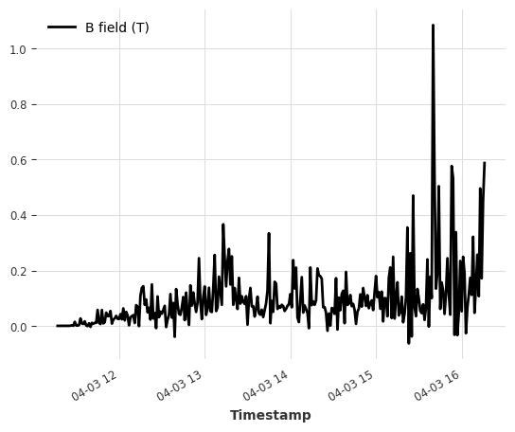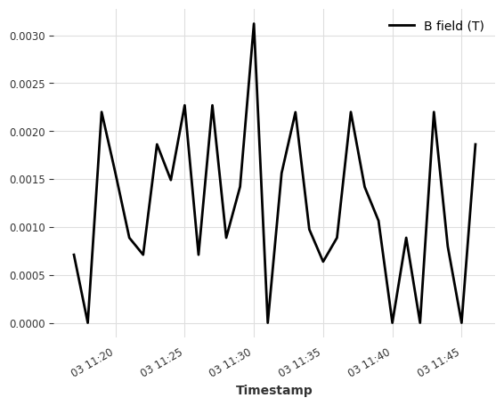

**01/08/24**

Since my midyear presentation is this Friday, I worked on creating my presentation for this class. I copied and pasted different graphs that showcase my data and the performance of my machine-learning models. During the last 15 minutes of class, I did a run-through and my timed presentation was approximately 7 minutes.

**01/10/24**

I worked on refining my presentation and did some more run-throughs to Tristan Devictor. I was able to take out some slides and condense information. By the end of class, my presentation is approximately 5 minutes long.